**SUMMARY**

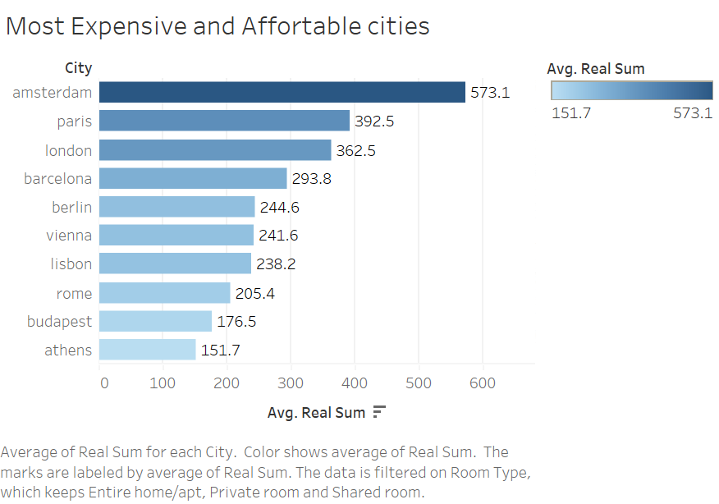

1. Amsterdam, Paris and London are the most expensive cities for Airbnb hosting, while Rome, Budapest and Athens are the most affordable ones.
2. The average price for a sharable room is the most affordable, while the average price for an entire home is the most expensive.
3. The location of the Airbnb property has no significant impact on the rental rates.

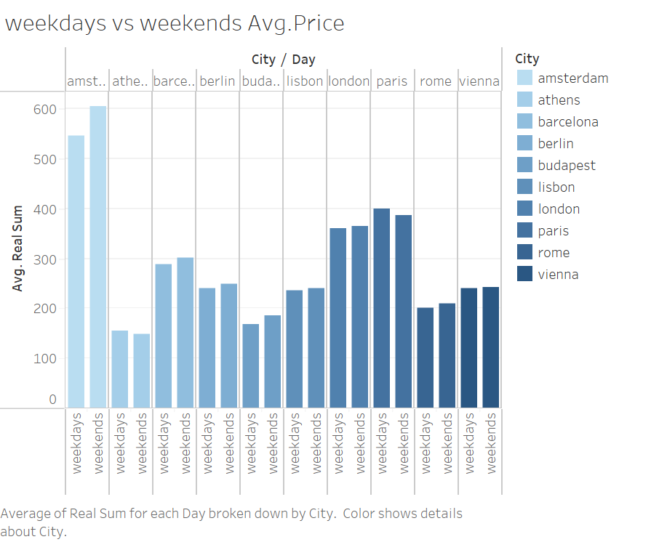

1. The prices of Airbnb rentals are higher during the weekends than weekdays for all the cities except Athens and Paris.
2. Some cities, such Lisbon, London and Vienna have a slight difference in rental rates between weekdays and weekends.

1. The type of room (private room, entire home, shared room) has the most significant impact on rental rates.
2. The cleanliness rating and overall guest satisfaction also influence rental rates.

Q4. Identifying important drivers in Sales/Booking occupancy across different cities?

Ans.

1. The number of Airbnb properties available is a crucial driver for booking occupancy.
2. The location and type of room also impact booking occupancy.
3. The rental rates play a significant role in determining booking occupancy, as higher rental rates could lead to lower occupancy rates

In conclusion, the insights provided through the analysis of Airbnb prices in European cities could be visualized through a Tableau dashboard. The dashboard could provide an overview of the most expensive and affordable cities for Airbnb hosting, differences between weekday and weekend booking patterns, important determinants of Airbnb prices and drivers of booking occupancy across different cities.